The release of this audit program to parties external to IBM requires the written approval of the Chief Auditor.
This program is intended as a guide for assessing risk management in this process through the performance of an audit or a similar engagement. Risk management is the process to identify, manage, and control potential events in order to provide reasonable assurance related to the achievement of IBM’s business and control objectives. IBM's control objectives fall into five broad categories:

- compliance with external laws and regulations, as well as IBM policies and procedures
- accomplishment of business objectives
- reliable information for financial reporting and decision making
- efficient operations, and
- safeguarding both intellectual and physical assets.

The control assessment questions are intended to address process objectives from the categories above and the risks to achieving those objectives. Objectives and risks in the actual process under review may differ based on organizational, operational, regulatory, and economic factors. As such, individuals performing the engagement must formulate a test strategy based on risks relative to the actual process under review, regardless of whether the risks are identified within this program.

DATE CHANGED | SECTION # | SUBTITLE IN SECTION | CHANGED BY (NAME) | COMMENTS
December 2025 | Process and Objective |  | Elena Jimenez de Scheer | Include considerations of continuous auditing
December 2024 | All |  | Elena Jimenez de Scheer | Some rewording for clarity, deletion of obsolete links and information, etc.
October 2024 | All |  | Elena Jimenez de Scheer | Exclusion of some Donations and some Sponsorship to avoid overlapping with Corporate Social Responsibility Audit program (18-80-00)
July 2024 | Process and Objective |  | Elena Jimenez de Scheer | Enhancement of section PLANNING: Self-Serve Information
December 2023 | Process and Objective |  | Elena Jimenez de Scheer | Created new section PLANNING: Self-Serve Information
December 2023 | Process and Objective | Audit Program Risk Alignment and the single test page | Elena Jimenez de Scheer | Change the description secondary test to be primary test
February 2023 | All | All | CA&AS | Converted from Notes into a Word document and into a Box folder

Table of Contents
PROCESS AND OBJECTIVE 3
PLANNING: Audit Program Risk Alignment 4
PLANNING: Data Analysis 5
PLANNING: Self-Serve Information 7
PLANNING: Reference Material 9
PLANNING: Fraud Template 10
CONTROL ASSESSMENT QUESTIONS 11
Key Control Question: 1. Management Review of Employee Disbursements 11
Primary Test: Employee Expense Accounts (EP001.P) 12
Key Control Question: 2. Payments and Reimbursements 14
Primary Test: Payments (PR001.P) 15
Primary Test: Procurement Bypasses (PR002.P) 17
Primary Test: Business Amenities and Gifts (PR003.P) 18
Primary Test: Membership and Sponsorships (PR004.P) 20
Instructions for WWBCIT 21
Request CEPAT access 23
Requesting Travel & Expense access 23
Request access to expense pre-approval tool (DocumentNow) 24
How to query concur 24
Find GOE 26

PROCESS AND OBJECTIVE

The primary focus in Management of Disbursement (MoD) reviews should be on the management team's role in verifying that submitted expenses align with company and country policies, and that fraud prevention controls are in place. Audit testing involves evaluating management's understanding of relevant global and local policies and guidelines on employee expenses, including any exceptions, and reviewing how these exceptions are documented.

Compliance with transportation, entertainment and business amenities (CTEBA) represents a global pre-approval process that must be completed before business amenities (transportation, accommodation/lodging, meals, gifts, entertainment, and waived event entrance fees, as set forth in Corporate Instruction FIN/LEG168), over a specified value are offered to officials, employees, or representatives of a government or government owned entities (GOE) in any country and all commercial parties that require CTEBA pre-approval as listed in FIN/LEG168. Business amenities and gifts should only be provided in conjunction with a legitimate business purpose.

Important note when auditing MoD:

While there are global process owners for CTEBA and Travel and Expense, compliance and accountability are the responsibility of the organization or country being audited.

There is a potential to overlap with the Travel and Expense audit program (18-15-00). It is important that we maintain a distinct audit objective that does not emulate the depth of testing that is contained in the Travel and Expense audit program or the Marketing and Events audit program (50-20-00). Please note that employee advances are not in scope of MoD audit but part of “Travel and Expense” audit program.

In addition, following commodity codes are part of the CSR audits (18-80-00) and should be excluded form MoD audits:
- X41 Donations - Corporate Social Responsibility usage only
- XW1 Business Unit Cash Donations

Following commodity codes are part of MoD audit. Nevertheless, the approval management related to permission to use restricted sponsorship commodity codes is in scope of the CSR audit. For getting the required understanding for the process please review this publisher GP Policies and Practices - Process for Sponsorships
- X42 Tradeshows and Other Sponsorships
- XW3 Non-Profit Sponsorships
- XW4 University Sponsorships

Important note regarding continuous auditing:

Since 2025, MoD has been part of the continuous auditing methodology. The concept of continuous auditing is to identify out-of-line or high-risk situations using data analytics. The assurance effort should be reinforced by a traditional audit in the country, market, or geography that shows the highest risk profile during the year. Before starting an MoD audit, make sure you review and understand the results of the continuous auditing exercise, and the traditional engagement should be agreed upon with the Continuous Auditing CA\&AS Manager.

PLANNING: Audit Program Risk Alignment

Management of Disbursements (MoD)

Defined Risk Area | Audit Risk Level | Key Control Question | Test Number
Management of Disbursements and Classification for Business Amenities and Gifts | High | Management Review of Employee Disbursements  Payments and Reimbursements  Procurement (PO and Non-PO)  Business Amenities and Gifts | EP001.P  PR001.P  PR002.P  PR003.P
Compliance with Transportation, Entertainment, and Business Amenities (CTEBA) | High | Management Review of Employee Disbursements  Payments and Reimbursements  Procurement (PO and Non-PO)  Business Amenities and Gifts | EP001.P  PR001.P  PR002.P  PR003.P
Membership and Sponsorships | Medium | Payments and Reimbursements | PR004.P

PLANNING: Data Analysis

Data analysis should be a part of every engagement where data is available in databases or data warehouses that can be accessed through query programs. This concept enhances the risk-based auditing approach, makes the audit process more efficient, and increases the productivity of the audit team. When the audit team does not have the skills required to perform these tasks, assistance should be sought from the Technology team.

All data used for analysis must be reconciled to an independent source so that the auditor has confidence that the universe is complete.

The audit team also needs to assess the local country laws with regards to data privacy to understand what can/cannot be provided for the audit, and understand if and to what level, the Global Expense Monitoring Compliance and Analysis Program (GEMCAP) has been implemented in that country. If GEMCAP has not been deployed, the GEMCAP specific reports will not be available. However, if there are no privacy restrictions, Global Travel Key Indicators and Cognos Audit tool reports can be run.
The Data Analysis engagement procedures in the Audit Manual (link internal to CA&AS members only) provide further suggestions.
This table shows what data can be reviewed and analysis techniques.

Data to be Analyzed | Analysis to be Performed | Possible Anomalies | Concern
Reports from the Global Expense Monitoring Compliance and Analysis (GEMCAP) program | - Volume of examinations, policy non-compliance, referrals to Investigations and overpayments  - Policy non-compliance/referrals by key expense category  - Employee detail | - Repetitive exceptions by a single employee  - Repetitive approvals of exceptions by a single manager | - Lack of monitoring of expenses  - Lack of awareness of guidelines by the employee and manager  - Unauthorized expenses  - Fraudulent expenses

PLANNING: Data Analysis (Continued)

Data to be Analyzed | Analysis to be Performed | Possible Anomalies | Concern
Key indicators reports | - Travel expense by key expense code/category (air travel, hotel, etc.)  - Exceptions and compliance by key expense code/category | - Excessive expenses by the group, sub-group, or individuals | - Inappropriate expenses  - Fraudulent expenses
Any business controls reports, including proactive or peer reviews | - Review findings and understand the testing performed | - Repetitive exceptions by a single employee  - Repetitive approvals of exceptions by a single manager | - Lack of monitoring of expenses  - Lack of awareness of guidelines by the employee and manager

DATA ANALYSIS

Please contact CA&AS Technology team for reports from CONCUR and corresponding analysis. These might include a list of business meal expenses, a list of all expense report comments, a list of every expense line item in Travel & Expense CONCUR, a subset of expense line items that reflect expenses not in policy defined by Global Travel, a list of unassigned credit card transactions, etc.

PLANNING: Self-Serve Information

Some information previously included in the Initial Data Request (IDR) items which continue to be relevant information in audits will now be extracted directly by the audit team. These are as in the table below. In addition, universes related C3, C4 and C5 could be obtained from the CA&AS Technology team – please check with them upfront. (C3. A report from CONCUR or the equivalent system showing all employee expense claims per country; C4. Reports from Concur of travel exceptions, including Travel Booking exceptions and Expense Report exceptions; C5. The universe of all purchases made during the audit period via PO, PO EXEMPT and Low Value, Buy@IBM/BOND, and APU, including commodity code). Check this link as well for Non Procurement Report Universe (ibm.com)

Information previously in IDR | Instructional Materials to download information and applying for access to the source tool
- Mission statement | The management of disbursement process is designed to ensure that expenses are properly reviewed and approved by management in line with internal policies. It also ensures that third-party expenses related to GOE and commercial parties comply with corporate instructions and external regulations.
- For countries is the use of Corporate Card is mandated who settles the outstanding balance (IBM or employee) | At the bottom of the page, you can click for country specifics, which includes who settles the outstanding balance for the Citi-Card.  IBM Corporate Card Program - Transition to Citi
- All Management Self-assessments performed during the audit period, and a summary list of any other issues/risks/concerns already identified by management, including the associated action plan(s)  - All risk assessments/evaluations approved during the audit period and any in draft pending approval relating to the process being audited | Instructions for WWBCIT
- A report from CONCUR or the equivalent system showing all employee expense claims per country  - Reports from CONCUR of travel exceptions, including Travel Booking exceptions and Expense Report exceptions  - The universe of all purchases/payments made during the audit period via PO, PO EXEMPT, Low Value split by country, Buy@IBM/BOND, and APU. Provide all fields available. | CA&AS Technology team
- CTEBA process documentation/guidelines that were in effect during the audit period. CTEBA Interaction Clip Levels for the countries valid during the audit period | CTEBA reference guide are available in publisher: CTEBA - Key Reference Materials (ibm.com)  CTEBA link/clips are available from FIN/LEG168: IBM Corporate Documents - FIN 168/LEG 168

PLANNING: Self-Serve Information (Continued)

Information previously in IDR | Instructional Materials to download information and applying for access to the source tool
- A list of low value commodity codes used in the region, together with their clip level  - A list of PO exempt commodity codes used in the region | Low Value: GP Policies and Practices - Low Value (ibm.com)  non-PO: GP Policies and Practices - Non-PO Categories (ibm.com)
- Details of the IBM and local law requirements for storage and retention of evidence submitted by the employees | Global Travel and Expenses follows Worldwide Records Management (WRM) and CIO122 guidelines  IBM Corporate Documents - Worldwide Records Management
- Provide instructions on how to access tools, such as and not limited to Expense pre-approval tool or country equivalent (local), CEPAT with global access (AccessHub), Travel & Expense (AccessHub) includes Expense Processor Read and COGNOS (AccessHub)  - Find GOE clarification | Request CEPAT access  Requesting Travel & Expense access  Request access to expense pre-approval tool (DocumentNow)  How to query concur  Find GOE

PLANNING: Reference Material

Request a link from the audit client to any local discretionary guidelines that go over and above global policy guidelines and approval requirements.

Refer to the following guidance:

- Business Conduct Guidelines (BCG)
IBM Corporate Documents - Business Conduct Guidelines
- Compliance with Transportation, Entertainment, and Business Amenities (CTEBA)
https://w3.ibm.com/w3publisher/cteba
- Corporate Instructions – CIO128 - IT Productivity Tools and Services Expense Eligibility
IBM Corporate Documents - CIO 128
- FIN 101 - Control of Disbursements
https://w3-03.ibm.com/ibm/documents/corpdocweb.nsf/ContentDocsByTitle/Corporate+Instruction+FIN+101IBM Corporate Documents - FIN 101
- FIN110 – Corporate Organization Letter – Delegation of Authority – Contribution
IBM Corporate Documents - COL 110
- Corporate Instruction CCR 101
https://w3-03.ibm.com/ibm/documents/corpdocweb.nsf/ContentDocsByTitle/Corporate+Instruction+CCR+101IBM Corporate Documents - CSR 101
- FIN 167 - Vendor Sourced Labor Services
IBM Corporate Documents - PROC 167
- FIN / LEG 168 – Corporate Instruction FIN/LEG168 - Business Amenities and Gifts
IBM Corporate Documents - FIN 168/LEG 168
- Global Accounts Payable
https://w3.ibm.com/w3publisher/global-accounts-payable
- IBM Travel Website, i.e., Travel & Expense by CONCUR
https://w3.ibm.com/travel/

PLANNING: Fraud Template

Fraud is any intentional act or omission designed to deceive others and resulting in the victim suffering a loss and/or the perpetrator achieving a gain. Fraud can be categorized into fraudulent financial reporting, misappropriation of assets, and improper or unauthorized expenditures.

Description of Fraud Risk | Typical Controls that should Detect the Fraud Risk | Testing Approach
Repetitive exceptions by the same employee | Cognos Audit tool reports, GEMCAP, BC Proactive Review reports | Inspect for repetitive exceptions by the same employee
Repetitive exception approvals by the same manager | Cognos Audit tool reports, GEMCAP, and Business Controls Proactive Review reports | Inspect for repetitive approvals of exceptions by the same manager without any rationale
Misclassifications: to circumvent policy, approval, or review. | Clear, understandable policy  Management review or approval | Carefully review policy, note particularly limits that could be exceeded under specific conditions (such as management approval)  Filter universe, mine data
Bypasses of CTEBA process could lead to amenities over the established country clip levels being provided to individuals from GOEs and Commercial Party that require CTEBA pre-approval without the required pre-approvals. This could result in non-compliance with IBMs policies and potentially other regulations. | The CTEBA Bypass Detection Process is an IBM legal and business controls requirement to ensure compliance with CTEBA. It is a risk-based approach that uses data from the following data sources:  - CTEBA Business Management (CBM) - CBM uses data sourced from Travel & Expense by CONCUR  - Buy@IBM or BOND  - Non-Purchase Order  - CEPAT  - Task ID referrals | Request a universe of expenses paid during the audit period and select a risk-based sample to ensure that all items that were required to go through a pre-approval tool did so. Review a list of CONCUR and Buy@IBM or BOND and non-PO submission.

Note: The probability and impact will vary depending on the organization/business unit that is being audited.

CONTROL ASSESSMENT QUESTIONS

Key Control Question: 1. Management Review of Employee Disbursements

Objective:
Are all business expenses claimed reasonable, documented, and approved as applicable? Are they in compliance with IBM policies?

Risk/Exposure:
Improper or invalid payments may be made to employees which could result in inappropriate or excessive expenses being incurred by IBM.

CONTROL ASSESSMENT QUESTIONS
Key Control Question: 1. Management Review of Employee Disbursements

Primary Test: Employee Expense Accounts (EP001.P)

Objective:
The objective of this risk-based test is to select samples from expenses from Travel & Expense by CONCUR, in Buy@IBM, BonD, or Non-PO that can be used to misclassify. This is to ensure that IBM employees are following IBM Policies, Instructions and Guidelines.
In addition, the objective of this test is to ensure that all employee expenses, including those claimed for external party business amenities, such as meals, transportation, accommodation, gifts, entertainment, and waived event entrance fees were reviewed and approved, as applicable, by management. This management review should encompass all expenses, including exceptions to global and local policies and guidelines.

Approach:
Using the reports from Travel & Expense by CONCUR and reports generated focus on selecting samples:
- Using a risk-based approach, review the data from these files for any outliers.
- Using risk-based analysis, select your sample by dollar value, frequency of requester, frequency of use of the specific code, as examples.
- Once the samples have been selected, request information from the submitter. Specifically:
  - Who were the Attendees present at the interaction/event, or the recipient of the business amenities or gifts that were provided?
  - What external party do they work for?
  - What was the purpose of the interaction/event?
  - Who reviewed and approved the expenses?
Use reports of all expenses, including reports or listings of potential exceptions to guidelines, to select for review. Pay attention to instances where there may be outliers. For example:
- A significant high number of expense accounts by one person
- High total expense amounts by one person
- Numerous exceptions allowed by the same manager
- Exceptions without any apparent business justification.
Assess the following, focusing on process and guideline adherence:
- Management demonstrated an understanding of reimbursement policy, including external party expenses, and their role in the process by reviewing and approving, as applicable, expenses according to guidelines, as required
- Exceptions were reviewed and approved, as applicable, by management
- There was clear business justification for the exceptions
- That in the case of repeated exceptions by the same employee, management was aware and acted as appropriate
- Proper internal IBM organizational pre-approvals, e.g., corporate community relations, expense restrictions.
- Are any local discretionary expense guidelines over and above the global policy? For example, some organizations require multiple levels of approval before travel can occur. If so, these more restrictive guidelines must be reviewed to ensure that the local policy restrictions and approvals have been documented and approved outside of Travel & Expense by CONCUR.
- In countries without local guidelines (legal, works council agreements, etc.) that do not restrict use of the IBM corporate card to business only, was the corporate card used for only business expenses?

CONTROL ASSESSMENT QUESTIONS
Key Control Question: 1. Management Review of Employee Disbursements
Primary Test: Employee Expense Accounts (EP001.P)
(Continued)

- Management reviewed for appropriate categorization of expenses and accurate completion of required information
- Expense account approval by management or authorized delegate was done in a reasonable amount of time
NOTE: Exceptions to guidelines are sometimes unavoidable; however, when there are exceptions, they should be explained and handled appropriately.
The following categories of exceptions, if not related to external party business amenities, are examples of exceptions no longer requiring management approval prior to reimbursement to the employee. Management is responsible for reviewing Travel & Expense by CONCUR dashboards and discussing the exceptions with their employees. There is no requirement for any documentation of the review by management of the Travel & Expense dashboard reports, and any action taken based on conversations with the submitting employees. However, time and resource permitting, CA&AS could select a sample to check for any trends emerging from the data, or pervasive behavior by the individuals and/or management.
To assist the auditor, use the following list for consideration. This list is not all inclusive.
Types of expenses that managers should review on an expense account are:
- Was the hotel in the IBM hotel guide, was it booked as a group hotel through Procurement, or was it a client-directed hotel?
- Are business meals documented, approved as applicable and within guidelines?
- Was the class of airfare in policy according to established procedures?
- Were IBM cell phone charges in accordance with guidelines?
- Was the corporate charge card used for only business expenses?
- Was the corporate card used for airfare, car rentals, and hotels?
- Were there any spousal expenses and did they adhere to guidelines? Note that IBM spouse expenses are taxable and must be appropriately reported. Customer spouses are treated as customers, and they have to be listed on the attendee list with justification in Travel & Expense by CONCUR.
- Are "other" or "none of the above" charges reasonable and properly supported?
- Did the employee document, when prompted, the explanation for any Travel & Expense exceptions?
- Did the employee adequately explain any potential duplicate payment highlighted by Travel & Expense?

CONTROL ASSESSMENT QUESTIONS

Key Control Question: 2. Payments and Reimbursements

Objective:
Are all payments and reimbursements for any expenses incurred reasonable, properly authorized, supported, receipt of goods or service verified, and in compliance with IBM policies and procedures?
Is there any evidence of improper payments, contributions, bribes, or any disbursements or expenditures which could be construed as such?
Are business amenities and gifts reasonable and reported to appropriate management? Is there a process to assess the appropriateness of business amenities and gifts and a review to ensure reasonableness?
Are any associations to which IBM belongs politically oriented, a lobbyist, or do they make contributions to politically oriented groups?

Risk/Exposure:
If adequate control is not exercised, recipients may be over-reimbursed or reimbursed for non-business-related expenses or for inappropriate or improperly approved expenses.
Any payment, transaction or business amenity which is or could be construed as inappropriate and/or exceeding policies and guidelines, could expose IBM legal or reputational risk. Such payments may also be an indicator of fraudulent activity.
Violation of IBM's policy regarding politically oriented contributions or organizations could result in accusations of political bias and jeopardize our business relationships.

CONTROL ASSESSMENT QUESTIONS
Key Control Question: 2. Payments and Reimbursements

Primary Test: Payments (PR001.P)

Objective:
To ascertain if there are any improper payments, contributions, bribes, or any disbursements or expenditures which could be construed as such.

Approach:
Select a judgmental sample of Buy@IBM (or BOND), Non-PO, or Travel & Expense by CONCUR payments made from the organization's ledger or the business development warehouse (BDW). The audit period should be restricted to the prior 12 months in accordance with the requirements of the Global Accounts Payable invoice payment verification process (IVPN). Look for the following when selecting the sample:
- Ledger accounts where improper payments, political contributions or bribes may be concealed, including convention or professional and trade meeting expenses, out-of-company training, consultant fees, legal fees, awards (non-payroll), deposits, miscellaneous, prepayments and other amortizable expenses, and advances to suppliers and vendors.
- Purchases of tickets to cultural and athletic events and follow through to disposition as they may be used as a way of entertaining vendors, government officials, or other parties who are not customers.
- Computer time buybacks from government, quasi-government, or political parties at excessive charge rates.
- Expenses charged to certain departments which have a high probability of "sensitive" payments, e.g., Government business unit marketing, senior country or local management departments (chief financial officer, country general manager, etc.).
- Duplicate payments.
Review the selected sample for the following attributes:
- Reasons for expenditure determined and reasonable?
- Fees vs. contracted amount correct?
- Necessary pre-approvals obtained?
- Were the payments charged into correct account minor for the purpose of the disbursement?
- Was the payment in compliance with IBM policies?
- Was evidence retained to demonstrate that goods and services were received? If not, the auditor must verify that all goods and services paid for were actually received via observation, or by requesting additional information from the client or the supplier. The buyer or requester should make these requests; CA&AS should NOT contact suppliers directly.
In some cases, the invoice and the purchase order will not have all items or services listed separately. In this case, the requester may need to get more information from the supplier or reference the statement of work when verifying that goods and services were received. The requester must retain proof of that each item or service was received.
- Was there evidence that independent verification of goods or services was performed, and that invoice accuracy was validated prior to payment?
- Was the invoice accurate per the terms of the contract?
- Was loaned or demo equipment supported by documentation and returned on the due date?
- If the payment was made to a car or cellular phone vendor, did the goods and services requested comply with local procedures for these types of expenses, including approvals?
- Were the local procedures adequate to assure that these goods and services were limited to only those with a business need?

CONTROL ASSESSMENT QUESTIONS
Key Control Question: 2. Payments and Reimbursements
Primary Test: Payments (PR001.P)
(Continued)
Review the process for credits. Assess controls to ensure that claims for shortages and returned goods are filed and resolved promptly, and that credit notes are issued by the supplier promptly. There are usually two situations for credits to occur:

- An employee may return goods (perhaps defective) to the supplier after the invoice was paid via the negative confirmation process. If the goods were returned by the employee, there should be a process to ensure that IBM received new goods or received a credit. This test can be quite difficult because there may not be an easy way to determine if there were any such returns or credits.
- For goods received at a receiving dock, if there were discrepancies, a credit memo is usually prepared and processed back through procurement and accounts payable. Using these source documents, the auditor can validate if the credit was processed properly and in a timely manner.
Select a sample of credits and ensure that the credit amount was properly recorded, and the credit amount was deducted from subsequent payments to the supplier or properly handled in another way.

CONTROL ASSESSMENT QUESTIONS
Key Control Question: 2. Payments and Reimbursements

Primary Test: Procurement Bypasses (PR002.P)

Objective:
To determine if management oversight is in place to prevent the bypass of procurement in selecting suppliers and/or making purchases.

Approach:
Review documentation and management policies to validate the control measures listed below. In selecting a sample, refer to PO-exempt / non-PO commodity codes (link provided in the self-serve section of this document).
Any expenses that do not fall into these categories must go through Procurement.
NOTE: Some categories also specify monetary limits which may assist in selecting a sample.

- Review Non-PO codes from the previous year. If the population is too large, select a sample. Repeat requests for payment to the same supplier and/or from the same requestor could be a sample selection criteria. Verify that expensed items did not require Procurement involvement.
- Review a selection of expense accounts to verify that expensed items did not require Procurement involvement. Ensure the proper Procurement channel was used.
- Determine if local management had procedures in place to prevent the bypass of Procurement. If a bypass did occur, validate that control procedures were implemented in a timely manner to ensure that repeat bypasses would be prevented.
- Obtain a listing of suppliers used in support of the organization for general purchasing and select a sample of suppliers to confirm that they had been approved by Procurement and that fair value analysis had been performed.

CONTROL ASSESSMENT QUESTIONS
Key Control Question: 2. Payments and Reimbursements

Primary Test: Business Amenities and Gifts (PR003.P)

Objective:
To ensure that all business amenities and gifts provided by IBM are reasonable and are reported to appropriate management.

Approach:
Business amenities and gifts are defined in FIN/LEG168. Payment may not be made in the form of money. Business amenities and gifts should not be offered or provided to an executive, official, or employee of any supplier, customer, or any other organization if doing so would influence or could reasonably give the appearance of influencing the organization's relationship with IBM. For example, and not limited to, a gift of nominal value can be provided, such as an IBM advertising novelty, if it is not prohibited by law or the customer's known business practices.
Acceptable practices in the commercial business environment, like offering education, transportation, entertainment, or other valuable items, may be unacceptable when dealing with government employees or those acting on the government's behalf. Such practices may violate federal, state, local, or foreign laws and regulations.
CTEBA pre-approval is required when the business amenity and gift recipient is a GOE or from a commercial party that requires CTEBA pre-approval, and the value exceeds CTEBA clip levels.

For external entity assessment, Audit can use ‘AskHR’ or query the trusted source FindGOE, to determine the external entity assessment. The audit team (or via the Technology team) must work with the Chief Data Office when pulling data from FindGOE to understand the external entity assessment. This will confirm if CTEBA is applicable to the external entity (see also self-serve section in this document).
The CA&AS team will access the CTEBA pre-approval tool (e.g., CEPAT) so that they can go in and test the samples directly. However, CA&AS is not testing the tool, it is testing the samples. CA&AS would check on the CTEBA Consequence Model to ensure the accountable local management team is responding as required.
From a universe of disbursements determine if the engagement includes an individual from a GOE or from a country where commercial parties require CTEBA pre-approval
- If the answer is yes, review if CTEBA pre-approval was obtained. Focus is on compliance with CTEBA Process/Tool.
- If the answer is no, proceed to the section labeled “Commercial Accounts”
Commercial Accounts
For commercial entities FIN/LEG168 defines the approval requirements based on the business amenity and gift value.
Review the local business amenity and gift procedure to determine that it is not contrary to corporate guidelines. Obtain a list of business amenities and gifts offered during the audit period and verify they were properly approved, made in accordance with the local procedure, and could not be construed as political contributions or bribes.

CONTROL ASSESSMENT QUESTIONS
Key Control Question: 2. Payments and Reimbursements
Primary Test: Business Amenities and Gifts (PR003.P)
(Continued)

Select a judgmental sample from the list above based on amount, nature of business amenity and gift, reason for offering it and review original documentation which supports the claim and validate that proper approvals were obtained.
If the business amenity and gift amount is above the published values within FIN/LEG168 for commercial recipients (non-GOE or a Commercial Party not from a country that require CTEBA pre-approval), ensure the expense was pre-approved as defined in FIN/LEG168.
Focus is on compliance with FIN/LEG168.

CONTROL ASSESSMENT QUESTIONS
Key Control Question: 2. Payments and Reimbursements

Primary Test: Membership and Sponsorships (PR004.P)

Objective:
To ensure IBM does not maintain questionable or politically oriented associations, such as and not limited to paying membership and sponsorship (please see relevant commodity codes in “Process and Objective” section of this document)

Approach:
Types of memberships are
- individual association membership, for individual participation on behalf of IBM in associations with membership dues.
- corporate association membership, for the IBM Corporation (not a specific individual) participation in association with membership dues.

Review the local procedure and verify that it agrees with corporate or operating unit guidelines. Check the list of memberships to verify the validity of the association, proper approval was obtained, and if the organization may be political.
For audits outside the US, verify that valid association codes show for association expenditures in ledger entries. Verify that outside meeting expense entries are coded with valid association codes.
Select a sample and review for original documentation, e.g., for membership is documented, and proper approvals obtained.
Sample selection tips:
- Include golf club memberships, health club memberships, etc. If there is a substantial down-payment which may be refundable in the future, ensure these payments are recorded as assets on the general ledger and are properly inventoried on a regular basis.
- The list of associations and memberships could also come from the vendor master file since most countries process these payments through accounts payable.
- Review local procedures to determine the rules for reimbursement. Also, review these "out-of- line" reimbursements for reasonableness.

Instructions for WWBCIT

Select “Manage Self Assessment” on the Menu of the left side.
Select as Assessment type “Global Process”
Select “CTEBA” and press “go”
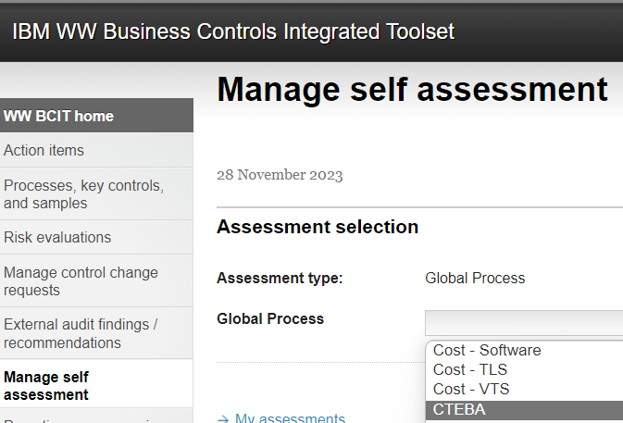

Scroll down the page and you will find all existing CTEBA MSAC

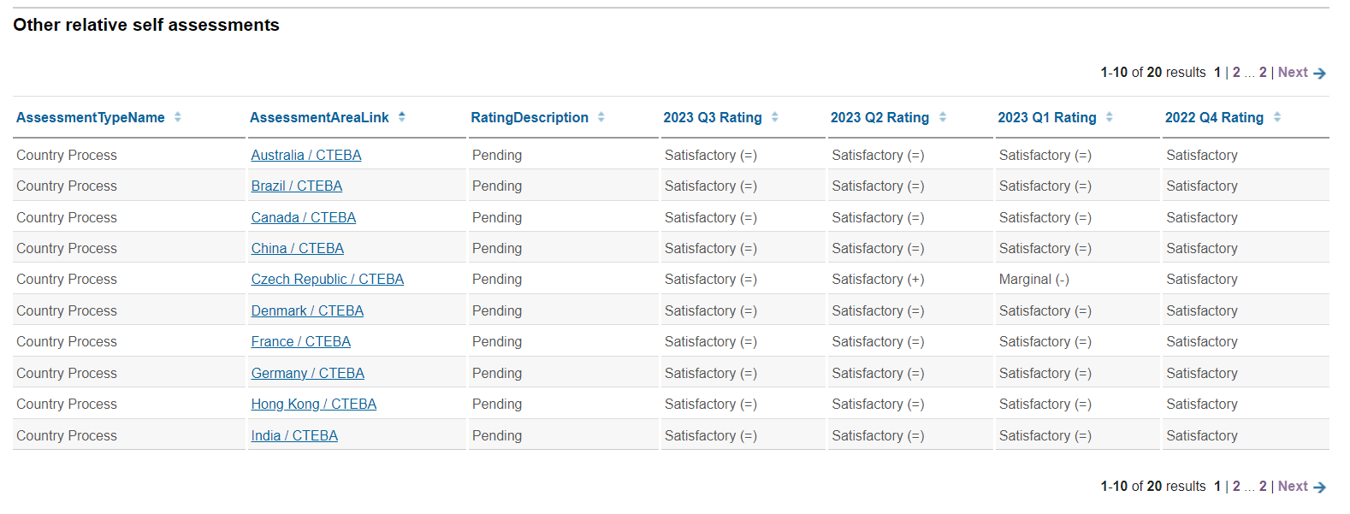

In addition, you can get the MSAC for the Market or Country you are reviewing to check whether any risks or similar has been identified and reported in the Market overall MSAC
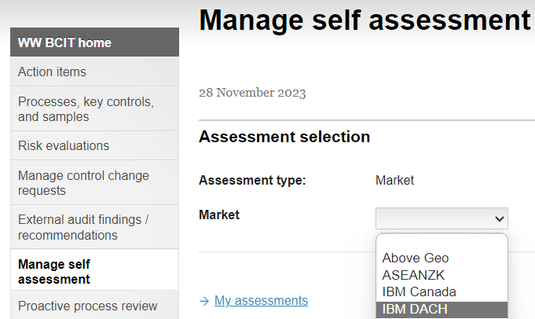

Furthermore, in “Quick search” you have find the details of the MSAC from prior quarters.

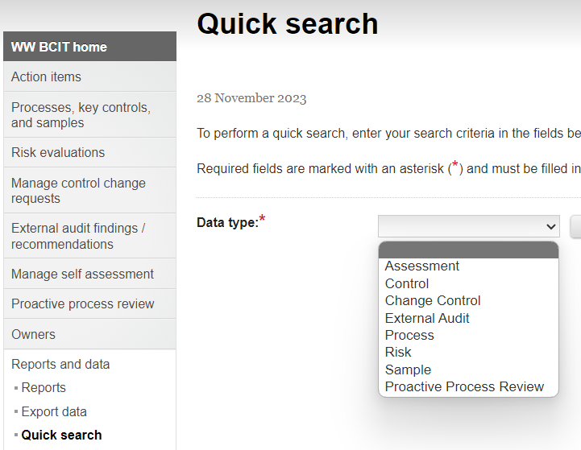

Request CEPAT access

- Go to IBM Access Hub
https://ibm.idaccesshub.com/ECMv6/request/applicationRequest

- Search for CEPAT and select ‘Request New Account’

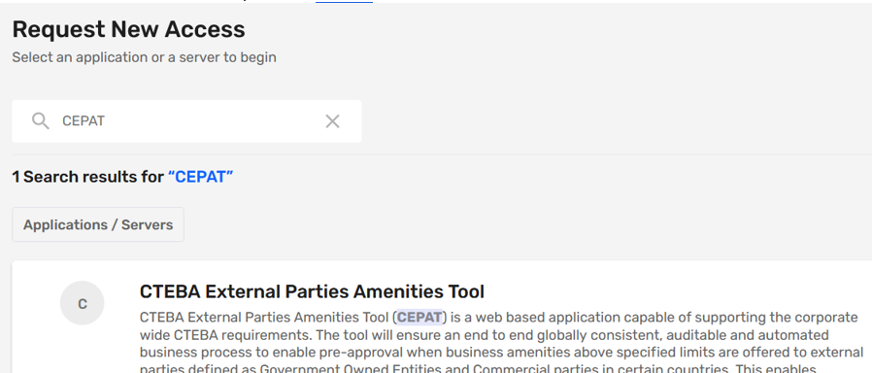

- Continue with the following steps selecting Version Access and Business justification details below.
  - Version of Access: CEPAT Global View
  - Business Justification: Add details of your Audit.

Requesting Travel & Expense access

- Log onto Access Hub: https://ibm.idaccesshub.com/ECMv6/request/manageRequest
- Enter your user ID and Password
- Click "Manage My Existing Access"
- Click 'Add New Access'
- Type in the application name - "Travel@IBM - Country Production Application Support (Web)" in the 'Start your search here' box.
- Click on the application name once it comes up
- If this is a first time to request access, click on 'Request New Account' and provide a name.
- If the request is to update access, click on 'Manage Access' to Add and Remove accesses.
- Read the term and check the box.
- Click on the 'Add' button to add 'Country/Company Access Information, clicking on the 'Add' button, will prompt the user to select which countries access is being requested for.
- Once the country (countries) is selected from the list, click 'Done'.
- Select the type of access required by clicking on 'Add' under Specific Roles.
  - Expense processor (read only) --> provides access to view expense forms directly in Concur.
  - Request Processor (read only) --> provides access to view pre-approval requests directly in Travel@IBM
- After the role(s) is selected, click on the first icon to confirm your selection and then click on 'Review & Submit' button.

- Review the access selected, add the business justification and read and click the disclaimer. **Note - to avoid the request being rejected by T&E be sure to indicate the audit engagement the access is being requested for, e.g., Management of Disbursements audit of [list countries or region in scope]
- Request will be submitted to your manager for approval and will then route to Travel and Expense for approval before going to the grant process.

Request access to expense pre-approval tool (DocumentNow)

Link to the application: https://documentnow-expense-approval.us1a.cirrus.ibm.com

How to query concur

1. Log into Travel & Expense (Concur). From w3 select the 'Travel & Expense' icon/app:
or use: https://w3.ibm.com/#/apps/travel


2. Once in Concur, select the form type you are interested in reviewing. (Request = pre-approval; Expense = expense report)

3. Example of searching for Expense Form, select 'Process Reports' (note - similar process for Requests, select 'Process Requests')
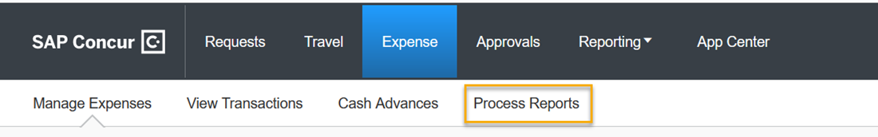

4. You will then be prompted to enter a search criteria.
Red Arrow - if you are interested in all expense forms for an employee, select 'Employee TalentID'. If you know the full ID indicate 'Equals' and enter into box outlined in purple.
Green Arrow - if you are interested in a specific expense form, select 'Report ID' - which is a field most Reporting. If you know the full ID indicate 'Equals' and enter into box outlined in purple.
(if you only know partial of one of the search criteria you can select 'Begins With' instead of 'Equals')
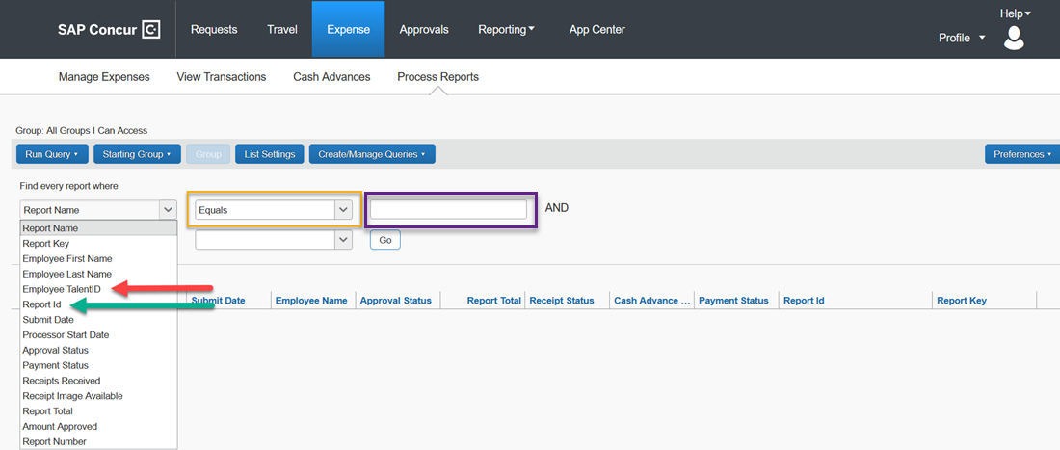

5. Select the expense form for review from the list provided based on your search criteria. (the example below was based on last name)
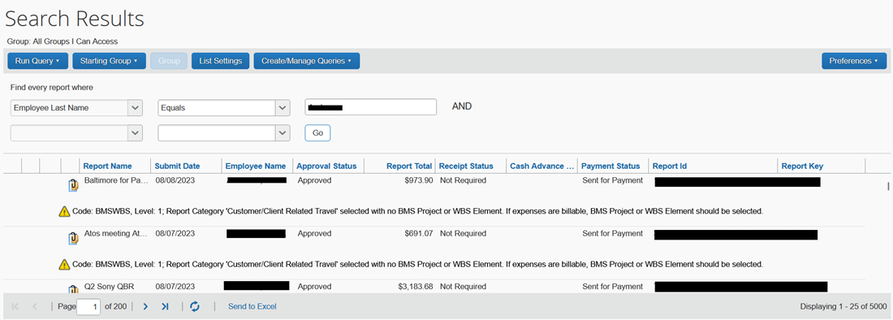

6. Once in the expense form you will see the expenses presented, and also have the option to review the Details and Receipts via the top menu. Note - this access is Read Only, so it is okay to navigate around the form to gain familiarity.
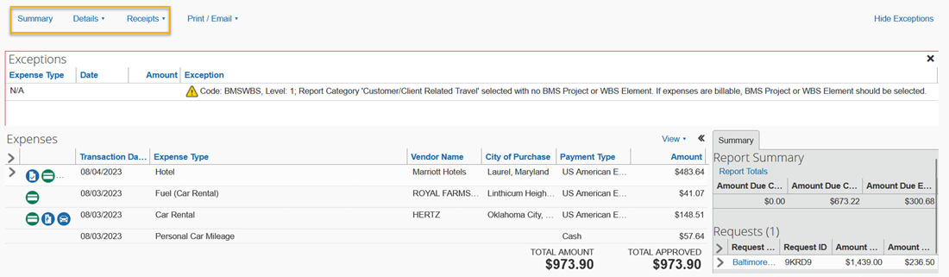

Find GOE
Message from CDO when receiving the FindGOE report:
This is a list of Customer Master Records for the requested country which are coded as a Government Entity (Y) or a State-Owned Entity (S) and may not be representative of how the legal entity would be categorized if the GOE Protocol (and specifically, the Waterfall) were applied.
- The list is not a substitute for conducting searches per the GOE Protocol and can only be used for the purposes of fulfilling the audit requirement.
- The list is accurate as of the time it is generated, MM/DD/YY. Shareholder structures change over time and so do GOE designations.
- This report is IBM Confidential.
- This report should not be shared with anyone outside the audit community.

